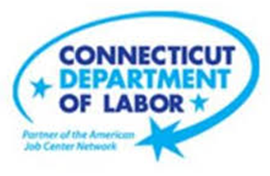

**NEW WEEKLY JOB POSTINGS FROM   
HELP WANTED ONLINE  
Office of Research**

**Week Ending June 30th, 2022: New Ads Down 9% Over the Week**WETHERSFIELD, July 1st, 2022 – During the week ending June 25th, there were 8,693 new postings, down 808 new ads or -9% over the week. This new ad count is the lowest level since mid-April. 48 percent of the one week decline occurred in three industries: Educational Services, Health Care & Social Assistance, and Manufacturing. The largest occupational decreases occurred in Licensed Practical & Vocational Nurses (-144 new ads), Marketing Managers (-46 new ads), and Retail Salesperson (-42 new ads). Employers with the largest decrease over the week include Eversource (-96 new ads), Hartford Public Schools (-84 new ads), and ASML (-76 new ads). Though down overall, hundreds of employers in the state added new ads over the week, including Community Health Center Inc. (+287 new ads), Amazon (+129 new ads), and Anthem Blue Cross (+111 new ads). The most recent weekly new ads total is up 35% from a year ago, which had 6,435 new ads during the week ending 6/26/21.  
  
  
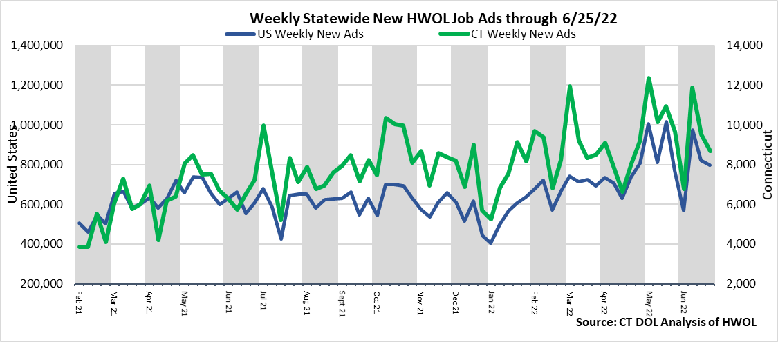  
**Industries** with the most new postings include Health Care & Social Assistance, Finance & Insurance, and Retail Trade.

**Occupations** with the most new postings include Registered Nurses, Retail Salespersons, Wholesale and Manufacturing Sales Representatives.

**Employers** with the most new postings include Community Health Center Inc., Capital One, and Amazon.

**The three industries with the most new job postings were:**

* **Health Care & Social Assistance** (1,886 new postings, -5% over the week)
* **Finance And Insurance** (1,002 new postings, +7% over the week)
* **Retail Trade** (807 new postings, +1% over the week)

  
 During the week ending June 25th, the total ad decline of 808 new ads or -9% is the net result of declines in 14 of 21 industries. The largest industry declines occurred in Educational Services (-184 new ads), Health Care & Social Assistance (-104 new ads), and Manufacturing (-101 new ads). Among the five increasing industries, the largest occurred in Other Services (+110 new ads or +78%). Over four weeks, the total decline of 1,146 new ads overlays 14 industry decreases and 7 increases. The largest four week decreases occurred in Pro., Sci., & Tech Services (-237 new ads), Accommodation & Food Services (-231 new ads), and Information (-220 new ads).   
  
For more information on total job ads by industry for Connecticut and its labor market areas, see the monthly report available here: <https://www1.ctdol.state.ct.us/lmi/hwol.asp>

**New Job Postings by Occupation** 

**The occupations with the most new postings were:**

* Registered Nurses (497 new postings, +13% over the week)
* Retail Salespersons (217 new postings, -16% over the week)
* Wholesale and Manufacturing Sales Representatives (170 new postings, -14% over the week)

**Employers with the Most New Job Postings**

Employers with the most new job postings during the week were mostly in Health Care, Finance & Insurance, and Retail Trade. The 25 employers shown above account for 22 percent of all new ads. 14 of 25 employers in the top 25 had over the week increases, 1 was unchanged, and 10 declined. Over four weeks, 18 employers in the top 25 had increases, one was unchanged, and 6 had decreases. The employer with the largest increase over both one and four weeks was Community Health Center, Inc., up 287 new ads over the week and up 299 over four weeks.   
  
**What is HWOL?**The **Conference Board Help Wanted Online**® Data Series (HWOL) measures the number of new, first-time Online job postings and jobs reposted from the previous month for over 16,000 Internet job boards, corporate boards and smaller job sites that serve niche markets and smaller geographic areas. To view more HWOL data, go to: <https://www1.ctdol.state.ct.us/lmi/hwol.asp>